3.3 Microfabrication Process

Microfabrication processes are capable of constructing the above-described sensor. The process consists of two main fabrication tasks: piezoelectric cantilever construction and magnetic material integration. Zinc oxide (ZnO) has a high strain-to-voltage coefficient in both the 31 and 33 directions and is highly suitable for piezoelectric sensors [22]. It is also bio compatible, and environmentally friendly. ZnO is typically deposited with sputtering or solution-based deposition techniques [*1*] and patterned with chemical or ion etching.

Rare-earth magnetic materials, such as alloys of Sm-Co, offer high magnetic energy products at room temperature and can be integrated into MEMS using sputtering or pulsed lased deposition (PLD) [2]. However, patterning of these materials is slow, using wet etching or ion-beam milling. Additionally, thick films or high aspect ratio structures composed of these materials become difficult, mainly due to the lack of a suitable electroplating process. To solve this problem, it is possible to embed a rare earth transition metal magnetic material, such as NdFeB, in a resin, then use a mold to pattern the magnetic resin composite [27]. Additionally, transition metal magnetic materials, such as FePt or CoPt, can be electroplated and also show relatively high magnetic energy products at room temperature [2,*2*].

Our proposed fabrication procedure is similar to others in MEMS [20]. The process involves six masks with one being a backside mask. The process will require double sided polished wafers, but the p+ etch stop removes the need for SOI wafers. However, if the doping process does not give the needed uniformity, SOI wafers may be used as well. Alternatively, if the KOH etching is too rough or if smaller spacing between columns is needed, reactive ion etching (RIE) may be used for the backside etch. The electrode area is patterned separately from the cantilevers since the accuracy of both the alignment and etching is not nearly as high. The detail fabrication steps are as follows:

1. Deposit silicon oxide using plasma enhanced chemical vapor deposition (PECVD) and pattern bottom electrode materials (titanium and platinum: Ti/Pt) with RIE etching according to the first mask in the electrode area (Fig. 4(a))
2. Deposit the piezoelectric material (ZnO) and pattern with wet etching according to the second mask in the electrode area (Fig. 4(a))
3. Deposit the top electrode material (Ti/Pt) and pattern with liftoff according to the third mask in the electrode area (Fig. 4(a))
4. Use RIE to etch the layers deposited in the preceding steps to define the cantilever with the forth mask (Fig. 4(b))
5. Deposit the magnetic proof mass using the mold approach (NdFeB) or electroplating (FePt or CoPt) with the fifth mask (Fig. 4(c))
6. Use backside exposure to pattern the backside of the silicon according to the sixth mask (Fig. 4(d))
7. Etch the backside of the silicon using KOH with a p+ epilayer as an etch stop (Fig. 4(e))
8. Release the cantilevers with a selective frontside RIE (Fig. 4(f))

|  |  |
| --- | --- |
|  |  |
| blank  Silicon  Piezoelectric cantilever  Magnetic proof mass  Metal interconnects | |

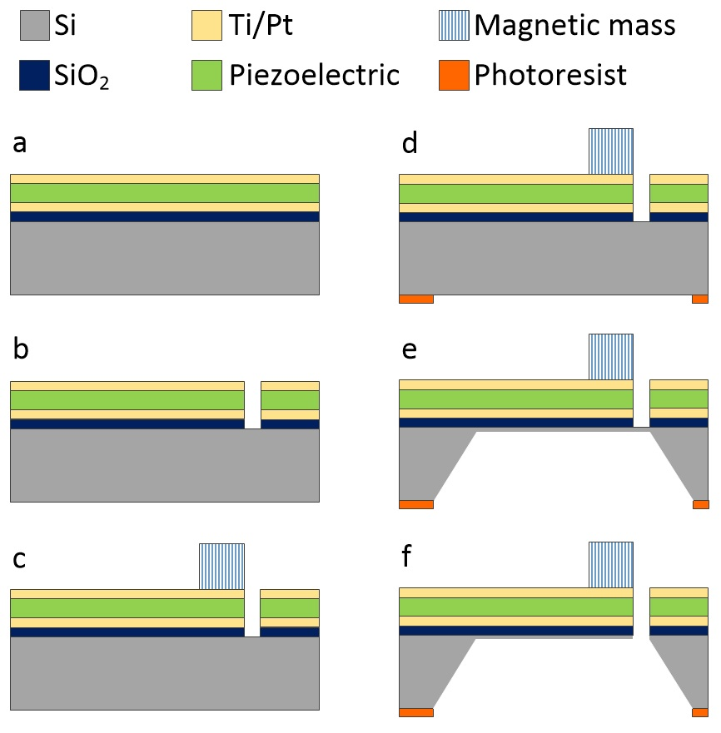

Figure 4: Magnetic cantilever fabrication. The patterning associated with steps 1-3 of the process described in the text are not shown due to image complexity and are represented by (a)

[*1*] Lamia Znaidi. Permanent magnet films for applications in microelectromechanical systems. *Journal of Magnetism and Magnetic Materials,* 209(1-3):75-79, 2000

[*2*] Tsung-Shune Chin. Sol–gel-deposited ZnO thin films: A review. *Materials Science and Engineering: B,* 174(1-3):18-30, 2010

On top of page 6:

Dr. Yoon has direct experience in the development of MEMS resonator based magnetic sensors [1-3], and strong expertise in microfabrication [25], piezoelectric [4], ferroelectric [5-7], ferromagnetic [8,9], and multiferroic devices [10,11].

1. S. Choi, S.-H. Kim, Y.-K. Yoon, and M.G. Allen, “A Magnetically Excited and Sensed MEMS-Based Resonant Compass,” *IEEE International Magnetics Conference (Intermag)*, San Diego, CA, May 8-12, 2006
2. S. Choi, S.-H. Kim, Yong-Kyu Yoon, and M.G. Allen, “A Magnetically Excited and Sensed MEMS-Based Resonant Compass,” *IEEE Trans. Magnetics*, vol. 42, no. 10, 2006, pp. 3506-3508
3. Seungkeun Choi, Yong-Kyu Yoon, Seong-Hyok Kim, and Mark G. Allen, “Nonlinear sensitivity enhancement of resonant microsensors and its application to low power magnetic sensing,” *Journal of Micromechanics and Microengineering*, no. 21, 045004 (12 pages), 2011

[25] Y-K Yoon, J-H Park, and Mark G Allen. Multidirectional uv lithography for complex 3-d mems structures. Journal of microelectromechanical systems, 15(5):1121–1130, 2006.

1. X. Wu, G. Yuan, S.-O. Choi, Y. Zhao, S.-H. Kim, Y.-K. Yoon, M.G. Allen, “Lateral Lamination Approach for Multilayer Piezoelectric Microactuator,” *Solid-State Sensor, Actuator, and Microsystems Workshop*, Hilton Head Island, SC, June 4-8, 2006, pp. 372 – 375
2. Kyoung-Tae Kim, Cheolbok Kim, David Senior, Dongsu Kim, and Yong-Kyu Yoon, "Microwave Characteristics of Sol-Gel based Ag-doped (Ba0.6Sr0.4)TiO3 Thin Films," *Thin Solid Film*, vol. 565, Aug. 2014, pp. 172-178
3. Yong-Kyu Yoon, J. S. Kenney, A.T. Hunt, and M.G. Allen, “Low-loss Microelectrodes Fabricated Using Reverse-side Exposure for Tunable Ferroelectric Capacitor,” *Journal of Micromechanics and Microengineering,* vol. 16, 2006, pp. 225-234
4. Yong-Kyu Yoon, Dongsu Kim, Mark G. Allen, J. Stevenson Kenney, and Andrew T. Hunt, “A Reduced Intermodulation Distortion Tunable Ferroelectric Capacitor-Architecture and Demonstration,” *IEEE Trans. Microwave Theory and Techniques,* vol. 51, no. 12, December 2003,pp. 2568-2576
5. Arian Rahimi and Yong-Kyu Yoon, "Study on Cu/Ni Superlattice Conductors for Reduced RF Loss," *IEEE Microwave Wireless Components Letters*, vol. 26, no. 4, pp. 258 - 260, April 2016
6. Arian Rahimi, Jiyu Wu, Xiaoyu Cheng, and Yong-Kyu Yoon, "Cylindrical Radial Superlattice Conductors for Low Loss Microwave Components," Journal of Applied Physics, vol. 117, no. 10, 103911 (7 pages), Mar. 14th, 2015
7. Yong Kyu Yoon, "Multiferroics for Frequency Agile Microwave Applications," The Journal of Korean-American Scientists and Engineering Association, vol. 42, no.v1, Oct. 2013, pp. 37-39
8. Kyoung-Tae Kim, Cheolbok Kim, Sheng-Po Fang, and Yong-Kyu Yoon, "Room Temperature Multiferroic Properties of (Fex, Sr1-x)TiO3 Thin Films," *Applied Physics Letters*, vol. 105, no. 10, 102903 (5 pages), Aug 2014